**Student management system**

**Sample Database application**

In this application we will describe the sample database application, called Student management system, which serve to illustrate the basic ER model concepts and their use in schema design. We list the date requirements for the database here, and then create its conceptual schema step-by-step as we introduce the modeling concepts of the ER model. The Student management system database keeps track of a school student, parents, teachers, exam results, course, exam, classroom-students, grade, Attendance. Suppose that after the requirements collection and analysis phase, the database designers provide the following description of the Student

* Student contains **student** as entity its attribute are student Id , email , password , first name , last name ,date of birth, phone number ,mobile number , parent id ,date of join, status, last login date, last login ip, gender where student id is primary key and parent id is foreign key from entity **parent** .
* Student contains **parent**  as entity its attribute are email , password , first name , last name ,date of birth, phone number ,mobile number , parent id ,date of join, status, last login date where parent id is primary key.
* Student contains **Exam result** as entity its attribute are exam id, student id, course id, marks where this entity contains three foreign key that are exam id from **Exam**, student id from **Student**, course id from **Course**.
* Student contains **Exam** as entity its attribute are exam id, exam type id, name, start date where exam id is primary key and exam type id is foreign key from entity **Exam type.**
* Student contains **Exam Type** as entity its attribute are exam type id, name, description where exam type is a primary key.
* Student contains **Attendance** as entity its attribute are date, student id, status, remark where student id is a foreign key.
* Student contains **Class room** as entity its attribute are classroom id,

Year, grade, section, status, remarks, teacher id where classroom id is primary key, grade is the foreign key from entity **Grade** and teacher id is foreign key from entity **Teacher**.

* Student contains **Classroom student** as entity its attribute are classroom id, student id where classroom id is foreign key from entity **Class room** and student id is foreign key from entity **student.**
* Student contains **Grade** as entity its attribute are grade id, name, description where grade id is the primary key.
* Student contains **Grade** as entity its attribute are course id, grade id, name, description where course id is the primary key and grade id is the foreign key from entity **Course**.
* Student contains **Teacher** as entity its attribute are teacher id, email , password , first name , last name ,date of birth, phone number ,mobile number , parent id ,date of join, status, last login date where teacher id is the primary key

**Entity tables:**

**Student**

|  |  |
| --- | --- |
| **Attribute** | **Data type** |
| Student_id(primary key) | Int(45) |
| Email | Varchar(45) |
| Password | Varchar(45) |
| Fname | Varchar(45) |
| Lname | Varchar(45) |
| Dob | Date |
| phone | Varchar(45) |
| mobile | Varchar(45) |
| Parent_id | Int(45) |
| Date_of_join | Date |
| Status | Boolean |
| Last_login_date | Date |
| Last_login_ip | Varchar(45) |
| Gender | Varchar(45) |

**Parents:**

|  |  |
| --- | --- |
| **Attribute** | **Data type** |
| Parent_id | Int(45) |
| Email | Varchar(45) |
| Password | Varchar(45) |
| fname | Varchar(45) |
| lname | Varchar(45) |
| dob | Date |
| phone | Varchar(45) |
| mobile | Varchar(45) |
| Last_login_date | Date |
| Last_login_ip | Varchar(45) |
| Status | Boolean |

**Exam Result:**

|  |  |
| --- | --- |
| **Attribute** | **Data type** |
| Exam_id | Int(45) |
| Student_id | Int(45) |
| Course_id | Int(45) |
| Marks | Varchar(45) |

**Exam:**

|  |  |
| --- | --- |
| **Attribute** | **Data type** |
| Exam_id(primary key) | Int(45) |
| Exam_type_id | Int(45) |
| Name | Varchar(45) |
| Start_date | Date |

**Exam type:**

|  |  |
| --- | --- |
| **Attribute** | **Data type** |
| Exam_type_id(primary key) | Int(45) |
| Name | Varchar(45) |
| description | Varchar(45) |

**Attendance:**

|  |  |
| --- | --- |
| **Attribute** | **Data type** |
| Date | Date |
| Student_id | Int(45) |
| status | Boolean |
| Remark | Varchar(45) |

**Classroom:**

|  |  |
| --- | --- |
| **Attribute** | **Data type** |
| Classroom_id(primary key) | Int(45) |
| Year | Year |
| Grade_id | Int(45) |
| Section | Char(3) |
| Status | Boolean |
| Remarks | Varchar(45) |
| Teacher_id | Int(45) |

**Teacher:**

|  |  |
| --- | --- |
| **Attribute** | **Data type** |
| Teacher_id(primary key) | Int(45) |
| Email | Varchar(45) |
| Password | Varchar(45) |
| fname | Varchar(45) |
| lname | Varchar(45) |
| dob | Date |
| phone | Varchar(45) |
| mobile | Varchar(45) |
| Last_login_date | Date |
| Last_login_ip | Varchar(45) |
| Status | Boolean |

**Classroom Student:**

|  |  |
| --- | --- |
| **Attribute** | **Data type** |
| Classroom_id | Int(45) |
| Student_id | Int(45) |

**Grade:**

|  |  |
| --- | --- |
| **Attribute** | **Data type** |
| Grade_id(primary key) | Int(45) |
| Name | Varchar(45) |
| Description | Varchar(45) |

**Course:**

|  |  |
| --- | --- |
| **Attribute** | **Data type** |
| Grade_id(primary key) | Int(45) |
| Name | Varchar(45) |
| Description | Varchar(45) |
| Course_id(primary key) | Int(45) |

**SQL FILE**

**show databases;**

**create database SMS;**

**use SMS;**

**drop database SMS;**

**create table Student(**

**Student_id int(20)primary key not null,**

**Email varchar(45),**

**Password varchar(45),**

**Fname varchar(45),**

**Lname varchar(45),**

**DOB date,**

**Phone varchar(15),**

**Mobile varchar(15),**

**Parents_id int(20),**

**date_of_join date,**

**Status boolean,**

**last_login_date date,**

**last_login_ip varchar(45)**

**);**

**select * from Student;**

**describe student;**

**create table Parents(**

**Parents_id int(20) primary key not null,**

**Email varchar(45),**

**Password varchar(45),**

**Fname varchar(45),**

**Lname varchar(45),**

**DOB date,**

**Phone varchar(15),**

**Mobile varchar(15),**

**date_of_join date,**

**Status boolean,**

**last_login_date date,**

**last_login_ip varchar(45)**

**);**

**select * from Parents;**

**describe Parents;**

**alter table Student add constraint `m_Parents_id` foreign key (Parents_id) references Parents (Parents_id);**

**create table teacher(**

**teacher_id int(20) primary key not null,**

**Email varchar(45),**

**Password varchar(45),**

**Fname varchar(45),**

**Lname varchar(45),**

**DOB date,**

**Phone varchar(15),**

**Mobile varchar(15),**

**date_of_join date,**

**Status boolean,**

**last_login_date date,**

**last_login_ip varchar(45)**

**);**

**create table Classroom(**

**Classroom_id int(20)primary key not null,**

**Years year,**

**Grade_id int(20),**

**section char(2),**

**status boolean,**

**remarks varchar(45),**

**teacher_id int(20)**

**);**

**alter table Classroom add constraint `N_teacher_id_fk` foreign key (teacher_id) references teacher(teacher_id);**

**create table Grade(**

**Grade_id int(20)primary key not null,**

**name varchar(45),**

**description varchar(45)**

**);**

**alter table Classroom add constraint `b_Grade_id_fk` foreign key (Grade_id) references Grade(Grade_id);**

**create table Course(**

**Course_id int(20)primary key not null,**

**Grade_id int(20),**

**name varchar(45),**

**description varchar(45)**

**);**

**alter table Course add constraint `_Grade_id_fk` foreign key (Grade_id) references Grade(Grade_id);**

**create table Classroom_Student(**

**Classroom_id int(20),**

**Student_id int(20)**

**);**

**alter table Classroom_Student add constraint `l_Classroom_id_fk`foreign key (Classroom_id)**

**references Classroom(Classroom_id);**

**alter table Classroom_Student add constraint `v_Student_id_fk`foreign key(Student_id)**

**references Student(Student_id);**

**create table Attandence(**

**Present_Date date,**

**Student_id int(20),**

**Status boolean,**

**remark text**

**);**

**alter table Attandence add constraint `mm_Student_id_fk`foreign key(Student_id)**

**references Student(Student_id);**

**create table Exam_Type(**

**exam_type int(20)primary key not null,**

**name varchar(45),**

**description varchar(45)**

**);**

**create table Exam(**

**Exam_id int(20)primary key not null,**

**exam_type int(20),**

**name varchar(45),**

**status_date date**

**);**

**alter table Exam add constraint`o_exam_type_fk`foreign key(exam_type) references Exam_type(exam_type);**

**create table Exam_result(**

**Exam_id int(20),**

**Student_id int(20),**

**Course_id int(20),**

**marks varchar(45)**

**);**

**alter table Exam_result add constraint `e_Exam_id_fk` foreign key(Exam_id)references Exam(Exam_id);**

**alter table Exam_result add constraint`p_Student_id_fk`foreign key(Student_id) references Student(Student_id);**

**alter table Exam_result add constraint`k_Course_id_fk` foreign key(Course_id) references Course(Course_id);**

**ER Diagram**

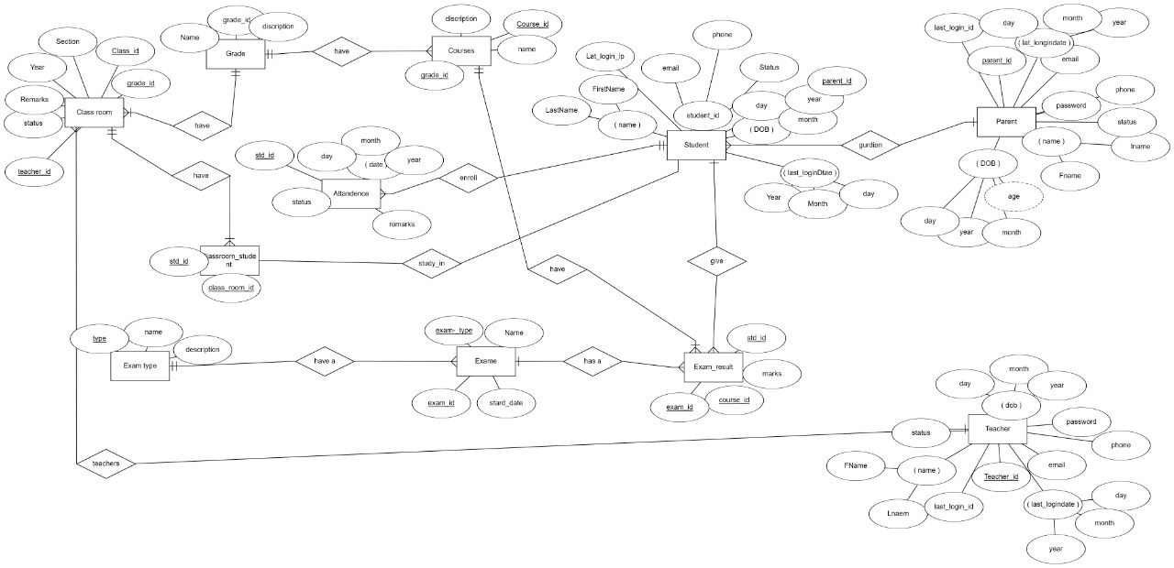

**ER Mapping**

